**18.Make a Calculator.**

**Exercise**

* **Make a Calculator. Take 2 integer numbers (a & b) from the user and an operation as follows**

**Press 1 : + (Addition) a + b**

**Press 2 : - (Subtraction) a - b**

**Press 3 : * (Multiplication) a * b**

**Press 4 : / (Division) a / b**

**Press 5 : % (Modulo or remainder) a % b**

**Calculate the result according to the operation given and display it to the user**

**Approach:**

**So here we did like this**

**Java : using case switch and take the integer input from the user and operation to them as the instructions are given in the question**

**Python : We take all int value as input and simply use if elif method**

**Solution 👇**

**Java :**

**import java.util.*;**

**public class CodeXam {**

**public static void main(String args[]) {**

**Scanner sc = new Scanner(System.in);**

**System.out.println("Enter Your First Number");**

**int a = sc.nextInt();**

**System.out.println("Enter Your Second Number");**

**int b = sc.nextInt();**

**System.out.println("Press 1 : + (Addition):  " +  a + " + " + b + "\nPress 2 :  - (Subtraction):  " +  a + " - " + b + "\nPress 3 :  * (Multiplication):  " +  a + " * " + b +"\nPress 4 :   / (Division):  " +  a + " / " + b +"\nPress 5 :  % (Modulo or remainder):  " +  a + " % " + b );**

**int operator = sc.nextInt();**

**/\*\***

**\* 1 -> +**

**\* 2 -> -**

**\* 3 -> \***

**\* 4 -> /**

**\* 5 -> %**

**\*/**

**switch(operator) {**

**case 1 : System.out.println(a+b);**

**break;**

**case 2 : System.out.println(a-b);**

**break;**

**case 3 : System.out.println(a*b);**

**break;**

**case 4 : if(b == 0) {**

**System.out.println("Invalid Division");**

**} else {**

**System.out.println(a/b);**

**}**

**break;**

**case 5 : if(b == 0) {**

**System.out.println("Invalid Division");**

**} else {**

**System.out.println(a%b);**

**}**

**break;**

**default : System.out.println("Invalid Operator");**

**}**

**}**

**}**

**output:**

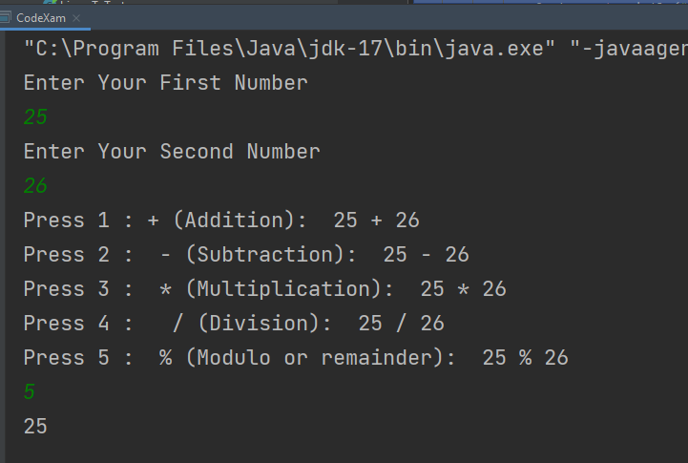

**Python :**

**a = int(input("Enter your 1st number: "))**

**b = int(input("Enter your 2nd number: "))**

**print(f"""**

**Press 1 : + (Addition): {a} + {b}**

**Press 2 :  - (Subtraction): {a} - {b}**

**Press 3 :  * (Multiplication): {a} * {b}**

**Press 4 :   / (Division): {a} / {b}**

**Press 5 :  % (Modulo or remainder): {a} % {b}""")**

**user_input = int(input())**

**if user_input == 1:**

**print(a+b)**

**elif user_input == 2:**

**print(a-b)**

**elif user_input == 3:**

**print(a*b)**

**elif user_input == 4:**

**print(a / b)**

**elif user_input == 5:**

**print(a % b)**

**else:**

**print("Invalid Input :(")**

**output:**

